Joint Probability | Concept, Formula and Examples - GeeksforGeeks
https://www.geeksforgeeks.org/engineering-mathematics/joint-probability-concept-formula-and-examples/

Joint Probability | Concept, Formula and Examples
Probability theory is a cornerstone of statistics, offering a powerful tool for navigating uncertainty and randomness in various fields, including business. One key concept within probability theory is Joint Probability, which enables us to analyse the likelihood of multiple events occurring simultaneously.
What is Joint Probability in Business Statistics?
In the realm of business statistics, Joint Probability refers to the likelihood of two or more events happening together or in conjunction with each other. It helps answer questions such as, "What is the probability of both event A and event B occurring in a business context?"
What does Joint Probability tell us?
Joint probability offers valuable insights into the likelihood of multiple events happening together. This helps us in several ways:
1. Co-occurrence: Joint probability helps us understand how likely it is for two or more events to happen at the same time. This is important for seeing how events are connected and the probability of them occurring together.
2. Risk Evaluation: In areas like finance and insurance, joint probability helps us assess the risk when multiple events overlap. For instance, it can estimate the chance of multiple financial instruments facing losses simultaneously.
3. Quality Check: Businesses can use joint probability to gauge the reliability and quality of their products or processes. It shows the likelihood of multiple defects or issues occurring at once, which allows for proactive quality improvement efforts.
4. Event Relationships: Joint probability can indicate if events are related or not. If joint probability significantly differs from the product of individual probabilities, it suggests events are connected, and the occurrence of one affects the likelihood of the other.
5. Decision Support: When businesses need to make choices involving multiple factors or events, joint probability provides a numerical foundation for decision-making. It helps assess how different variables together impact the desired outcome.
6. Resource Management: In situations with limited resources, understanding joint probability helps optimise resource allocation. For example, in supply chain management, it can estimate the chance of multiple supply chain disruptions happening at the same time, enabling better risk management strategies.
Formula for Joint Probability
The formula for calculating joint probability hinges on whether the events are independent or dependent:
1. For Independent Events
When events A and B are independent, meaning that the occurrence of one event does not impact the other, we use the multiplication rule:
P(A∩B) = P(A) x P(B)
Here, P(A) is the probability of occurrence of event A, P(B) is the probability of occurrence of event B, and P(A∩B) is the joint probability of events A and B.
2. For Dependent Events
Events are often dependent on each other, meaning that one event's occurrence influences the likelihood of the other. Here, we employ a modified formula:
P(A∩B) = P(A) x P(B|A)
Here, P(A) is the probability of occurrence of event A, P(B|A) is the conditional probability of occurrence of event B when event A has already occurred, and P(A∩B) is the joint probability of events A and B.
Examples of Joint Probability
Example 1: Independent Events
Suppose you are running an e-commerce platform, and you want to find the probability of a customer purchasing a red shirt (event A) and a blue hat (event B) independently. Find out the Joint Probability where
P(A): The probability of a customer buying a red shirt is 0.3.
P(B): The probability of a customer purchasing a blue hat is 0.2.
Solution:
P(A∩B) = P(A) x P(B)
P(A∩B) = P(customer buying a red shirt) x P(customer buying a blue hat)
P(A∩B) = 0.3 x 0.2
P(A∩B) = 0.6

Example 2: Dependent Events
Imagine you are in the insurance business, and you want to determine the probability of a customer filing a claim (event A) and receiving a payout (event B), given that a claim was filed. Find out the Joint Probability where
P(A): The probability of a customer filing a claim is 0.1.
P(B∣A): P(B∣A): The probability of a customer receiving a payout given that a claim was filed is 0.8.
Solution:
P(A∩B) = P(A) x P(B|A)
P(A∩B) = P(customer filing a claim) x P(customer receiving a payout given that a claim was filed)
P(A∩B) = 0.1 x 0.8
P(A∩B) = 0.08
Difference between Joint Probability and Conditional Probability
Joint Probability (P(A∩B))
Joint Probability addresses the simultaneous occurrence of events A and B without considering any specific order or sequence. It quantifies the combined probability of events occurring together, providing insights into their co-occurrence in a business context.
Conditional Probability (P(B|A))
Conditional Probability focuses on the probability of event B happening, given that event A has already occurred. This kind of probability is utilised when the occurrence of one event influences the likelihood of another event, making it a valuable tool for understanding cause-and-effect relationships in business statistics.
Basis | Joint Probability | Conditional Probability
Definition | Probability of multiple events occurring together. | Probability of an event occurring given another event has occurred.
Application | Provides insights into the combined occurrence of events, often used in risk assessment, quality control, and event co-occurrence analysis. | Useful for understanding cause-and-effect relationships; i.e., helps predict outcomes based on known information.
Focus | Focuses on events occurring together, regardless of order. | Focuses on events that depend on or are influenced by the occurrence of another event.
Example | Probability of a customer buying both a red shirt (A) and a blue hat (B) independently. | Probability of a customer buying a blue hat (B) given that he has already bought a red shirt (A).
In conclusion, Joint probability plays a pivotal role in business statistics, offering a framework to assess the likelihood of multiple events occurring concurrently. By harnessing joint probability, businesses gain valuable insights into the combined outcomes of different events, aiding in decision-making, risk assessment, quality control, and various other applications in the corporate world.

Bayes' Theorem - GeeksforGeeks
https://www.geeksforgeeks.org/maths/bayes-theorem/
Bayes' Theorem
Bayes' Theorem is a mathematical formula used to determine the conditional probability of an event based on prior knowledge and new evidence.
It adjusts probabilities when new information comes in and helps make better decisions in uncertain situations.
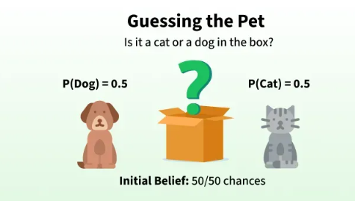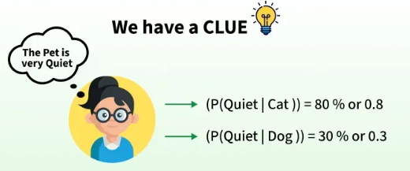
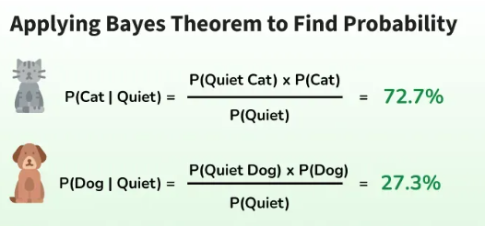

Bayes' Theorem helps us update probabilities based on prior knowledge and new evidence. In this case, knowing that the pet is quiet (new information), we can use Bayes' Theorem to calculate the updated probability of the pet being a cat or a dog, based on how likely each animal is to be quiet.
Bayes Theorem and Conditional Probability
Bayes' theorem (also known as the Bayes Rule or Bayes Law) is used to determine the conditional probability of event A when event B has already occurred.
The general statement of Bayes’ theorem is “The conditional probability of an event A, given the occurrence of another event B, is equal to the product of the probability of B, given A, and the probability of A divided by the probability of event B.” i.e.
For example, if we want to find the probability that a white marble drawn at random came from the first bag, given that a white marble has already been drawn, and there are three bags each containing some white and black marbles, then we can use Bayes’ Theorem.
Bayes Theorem Formula
For any two events A and B, Bayes's formula for the Bayes theorem is given by:
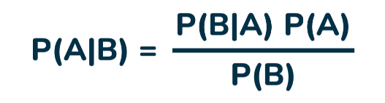
Formula for the Bayes theorem
Where,
- P(A) and P(B) are the probabilities of events A and B; also, P(B) is never equal to zero.
- P(A|B) is the probability of event A when event B happens,
- P(B|A) is the probability of event B when A happens.
Bayes Theorem Statement
Bayes' Theorem for n sets of events is defined as,
Let E1, E2,…, En be a set of events associated with the sample space S, in which all the events E1, E2,…, En have a non-zero probability of occurrence. All the events E1, E2,…, E form a partition of S. Let A be an event in space S for which we have to find the probability, then according to Bayes theorem,
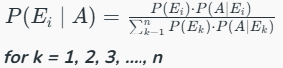
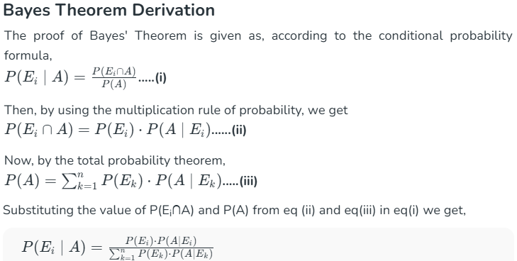
Bayes’ theorem is also known as the formula for the probability of “causes”. As we know, the Ei‘s are a partition of the sample space S, and at any given time, only one of the events Ei occurs. Thus, we conclude that the Bayes theorem formula gives the probability of a particular Ei, given that event A has occurred.
Terms Related to Bayes' Theorem
After learning about Bayes theorem in detail, let us understand some important terms related to the concepts we covered in the formula and derivation.
Hypotheses
- Hypotheses refer to possible events or outcomes in the sample space; they are denoted as E1, E2, …, En.
- Each hypothesis represents a distinct scenario that could explain an observed event.
Priori Probability
- Priori Probability P(Ei) is the initial probability of an event occurring before any new data is taken into account.
- It reflects existing knowledge or assumptions about the event.
- Example: The probability of a person having a disease before taking a test.
Posterior Probability
- Posterior probability (P(Ei∣A) is the updated probability of an event after considering new information.
- It is derived using the Bayes Theorem.
- Example: The probability of having a disease given a positive test result.
Conditional Probability
- The probability of an event A based on the occurrence of another event B is termed conditional Probability.
- It is denoted as P(A|B) and represents the probability of A when event B has already happened.
Joint Probability
- When the probability of two or more events occurring together and at the same time is measured, it is marked as Joint Probability.
- For two events A and B, it is denoted by joint probability is denoted as P(A∩B).
Random Variables
- Real-valued variables whose possible values are determined by random experiments are called random variables.
- The probability of finding such variables is the experimental probability.
Bayes Theorem Applications
Bayesian inference is very important and has found application in various activities, including medicine, science, philosophy, engineering, sports, law, etc., and Bayesian inference is directly derived from Bayes theorem.
Some of the Key Applications are:
- AI & Machine Learning → Used in Naïve Bayes classifiers to predict outcomes.
- Medical Testing → Finding the real probability of having a disease after a positive test.
- Spam Filters → Checking if an email is spam based on keywords.
- Weather Prediction → Updating the chance of rain based on new data.
Also Check
Bayes' Theorem Real Life Applications of Bayes Theorem
Difference Between Conditional Probability and Bayes Theorem
The difference between Conditional Probability and Bayes's theorem can be understood with the help of the table given below.
Bayes Theorem | Conditional Probability
Bayes's Theorem is derived using the definition of conditional probability. It is used to find the reverse probability. | Conditional Probability is the probability of event A when event B has already occurred.
Formula: P(A|B) = [P(B|A)P(A)] / P(B) | Formula: P(A|B) = P(A∩B) / P(B)
Purpose: To update the probability of an event based on new evidence. | Purpose: To find the probability of one event based on the occurrence of another.
Focus: Uses prior knowledge and evidence to compute a revised probability. | Focus: Direct relationship between two events.
Theorem of Total Probability
Let E1, E2,…., En be mutually exclusive and exhaustive events of a sample space S, and let E be any event that occurs with some Ei​. Then, prove that :
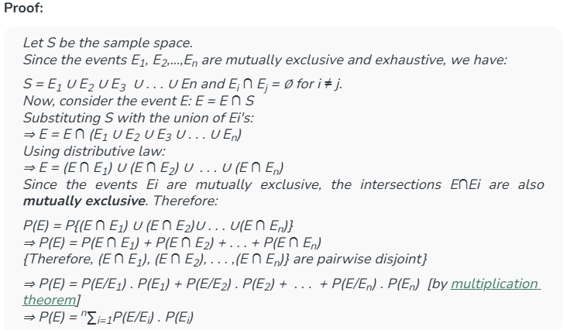

Bayes Theorem for Programmers-
- Bayes Theorem in Artificial Intelligence
- Bayes Theorem in Machine Learning
- Bayes’ Theorem in Data Mining

Solved Examples of Bayes' Theorem
Example 1: A person has undertaken a job. The probabilities of completion of the job on time with and without rain are 0.44 and 0.9, and 5, respectively. If the probability that it will rain is 0.45, then determine the probability that the job will be completed on time.
Solution:
Let E1 be the event that the mining job will be completed on time and E2 be the event that it rains. We have,
P(A) = 0.45,
P(no rain) = P(B) = 1 − P(A) = 1 − 0.45 = 0.55
By multiplication law of probability,
P(E1) = 0.44, and P(E2) = 0.95
Since, events A and B form partitions of the sample space S, by total probability theorem, we have
P(E) = P(A) P(E1) + P(B) P(E2)
⇒ P(E) = 0.45 × 0.44 + 0.55 × 0.95
⇒ P(E) = 0.198 + 0.5225 = 0.7205
So, the probability that the job will be completed on time is 0.7205
Example 2: There are three urns containing 3 white and 2 black balls, 2 white and 3 black balls, and 1 black and 4 white balls, respectively. There is an equal probability of each urn being chosen. One ball is equal probability chosen at random. What is the probability that a white ball will be drawn?
Solution:
Let E1, E2, and E3 be the events of choosing the first, second, and third urn respectively. Then,
P(E1) = P(E2) = P(E3) = 1/3
Let E be the event that a white ball is drawn. Then,
P(E/E1) = 3/5, P(E/E2) = 2/5, P(E/E3) = 4/5
By theorem of total probability, we have
P(E) = P(E/E1) . P(E1) + P(E/E2) . P(E2) + P(E/E3) . P(E3)
⇒ P(E) = (3/5 × 1/3) + (2/5 × 1/3) + (4/5 × 1/3)
⇒ P(E) = 9/15 = 3/5
Example 3: A card from a pack of 52 cards is lost. From the remaining cards of the pack, two cards are drawn and are found to be both hearts. Find the probability of the lost card being a heart.
Solution:
Let E1, E2, E3, and E4 be the events of losing a card of hearts, clubs, spades, and diamonds respectively.
Then P(E1) = P(E2) = P(E3) = P(E4) = 13/52 = 1/4.
Let E be the event of drawing 2 hearts from the remaining 51 cards. Then,
P(E|E1) = probability of drawing 2 hearts, given that a card of hearts is missing
⇒ P(E|E1) = 12C2 / 51C2 = (12 × 11)/2! × 2!/(51 × 50) = 22/425
P(E|E2) = probability of drawing 2 clubs ,given that a card of clubs is missing
⇒ P(E|E2) = 13C2 / 51C2 = (13 × 12)/2! × 2!/(51 × 50) = 26/425
P(E|E3) = probability of drawing 2 spades ,given that a card of hearts is missing
⇒ P(E|E3) = 13C2 / 51C2 = 26/425
P(E|E4) = probability of drawing 2 diamonds ,given that a card of diamonds is missing
⇒ P(E|E4) = 13C2 / 51C2 = 26/425
Therefore,
P(E1|E) = probability of the lost card is being a heart, given the 2 hearts are drawn from the remaining 51 cards
⇒ P(E1|E) = P(E1) . P(E|E1)/P(E1) . P(E|E1) + P(E2) . P(E|E2) + P(E3) . P(E|E3) + P(E4) . P(E|E4)
⇒ P(E1|E) = (1/4 × 22/425) / {(1/4 × 22/425) + (1/4 × 26/425) + (1/4 × 26/425) + (1/4 × 26/425)}
⇒ P(E1|E) = 22/100 = 0.22
Hence, The required probability is 0.22.
Example 4: Suppose 15 men out of 300 men and 25 women out of 1000 are good orators. An orator is chosen at random. Find the probability that a male person is selected.
Solution:
Given,
- Total Men = 300
- Total Women = 1000
- Good Orators among Men = 15
- Good Orators among Women = 25
Total number of good orators = 15 (from men) + 25 (from women) = 40
Probability of selecting a male orator:
P(Male Orator) = Numbers of male orators / total no of orators = 15/40 = 3/8
Example 5: A man is known to speak the lies 1 out of 4 times. He throws a die and reports that it is a six. Find the probability that it is actually a six.
Solution:
In a throw of a die, let
E1 = event of getting a six,
E2 = event of not getting a six and
E = event that the man reports that it is a six.
Then, P(E1) = 1/6, and P(E2) = (1 - 1/6) = 5/6
P(E|E1) = probability that the man reports that six occurs when six has actually occurred
⇒ P(E|E1) = probability that the man speaks the truth
⇒ P(E|E1) = 3/4
P(E|E2) = probability that the man reports that six occurs when six has not actually occurred
⇒ P(E|E2) = probability that the man does not speak the truth
⇒ P(E|E2) = (1 - 3/4) = 1/4
Probability of getting a six ,given that the man reports it to be six
P(E1|E) = P(E|E1) × P(E1)/P(E|E1) × P(E1) + P(E|E2) × P(E2) [by Bayes theorem]
⇒ P(E1|E) = (3/4 × 1/6)/{(3/4 × 1/6) + (1/4 × 5/6)}
⇒ P(E1|E) = (1/8 × 3) = 3/8
Hence the probability required is 3/8.
Keywords: for Condition
Found to be
Given that
If a

Practice Problem Based on Bayes' Theorem
Question 1: A medical test for a disease is 95% accurate in detecting the disease (True Positive Rate). The probability of a person having the disease is 0.01 (1%). If a person tests positive for the disease, what is the probability that they actually have the disease? (Assume that the false positive rate is 5%).
 | Detected | Not Detected
Disease  p(D)=0.01 | TP 0.95 | FN
No Disease  p(ND)=0.99 | FP 0.05 | TN

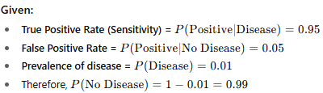
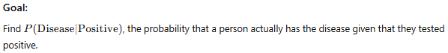
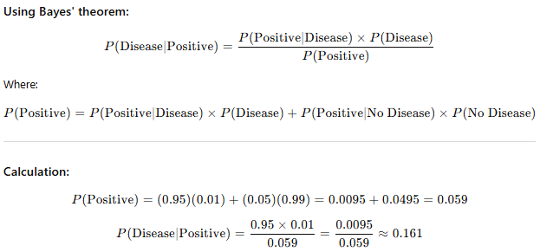

Question 2: A bag contains 4 red balls and 6 blue balls. Two balls are drawn at random, and one of them is red. What is the probability that the second ball drawn is also red, given that the first ball was red?
Given:
- Total balls: 4 red + 6 blue = 10 balls.
- Two balls are drawn at random without replacement.
- One of the drawn balls is red.
- The first ball drawn was red.
- Find the probability that the second ball drawn is also red, given the first ball was red.

Step-by-step solution:
Since the first ball drawn was red, this affects the total number of balls remaining for the second draw.
- After drawing the first red ball:
  - Remaining red balls: 4−1=34 - 1 = 34−1=3
  - Remaining blue balls: 6 (unchanged)
  - Total balls remaining: 10−1=910 - 1 = 910−1=9
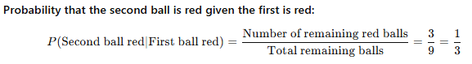
Final answer:
The probability that the second ball is red, given that the first ball was red, is 1/3 or about 33.3%.

Question 3: In a factory, 80% of the products are produced by Machine A and 20% by Machine B. Machine A produces 2% defective items, while Machine B produces 5% defective items. If a product is found to be defective, what is the probability that it was produced by Machine A?

 | Defective | Not Defective
Machine A  p(MA)=0.8  P(MA/Def)=? | TP 0.02 | FN
Machine B  p(MB)=0.2 | FP 0.05 | TN

TP => True Positive
FN =>False Negative
FP=> False Positive
FN=> False Negative
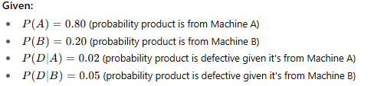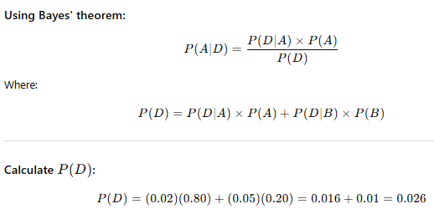
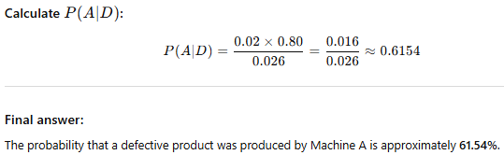

Question 4: A survey shows that 70% of people like ice cream, and 40% of people like both ice cream and chocolate. What is the probability that a person likes chocolate, given that they like ice cream?
Answer:-
- 16.1%.
- 33.33%.
- 61.5%.
- 57.1%.

